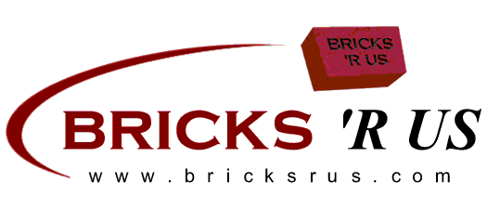
Alumni Bricks
Etowah Varsity Baseball

BUY A BRICK PROGRAM
We are raising money to help pay for an alumni walkway. The bricks will be placed from the back door of the field house to the gate at 1st Base. This is a fundraiser to continue the improvement made on the fields and allow your name as an alumni to carry on the legacy of Etowah Baseball.
$50.00
- - - - - - - - - - - - - - - - - - - - - - - - - - - - - - - - - -
Yes, we’d like to reserve a permanent brick. Please engrave our brick as follows:

ANY SYMBOL IS CONSIDERED ONE SPACE (PERIOD, COMMA, DASH)
ALL TEXT IS CENTERED UNLESS OTHERWISE NOTED
4 x 8 Brick

4 x 8 Brick

EXAMPLE
T | Y | L | E | R |  | B | U | S | H
2 | 0 | 1 | 4 | - | 2 | 0 | 1 | 9

PLEASE RETURN THIS FORM AND YOUR CHECK PAYABLE TO:

Attalla Diamond Club
Attn: Blake Bone
201 Case Ave
Attalla, Al 35954

Name: ________________________________________ Phone: (_______) _________________________
Address: _______________________________________________________________________________
City: ____________________________________ State: __________________ Zip: __________________
Email Address: ___________________________________________ Amount Paid: ___________________

FORMS MUST BE RECEIVED BY December 31, 2022.
If you have any questions, please call Charlie Bush @ 256-458-5558.
$50.00

